Round robin VS Priority Queue

Names and IDs :
1.Nadeen Mohamed Farid 20245083 (Leader)
2.Hassan Ahmed Hassan 20245023
3.Amany Mohamed Ismael 20245012
4.Manar Mahmoud sayed 20245079 (Manar Selim in github)
5.Magda Ahmed Abo El-yazid 20245062
6.Mohamed Walid Abd El-Maged 20245073 (Saltawy in github)
7.Fadwa Hussin Ibrahim 20245057

Sections:
1.Input section (2~3)
2.Process table (4)
3.Results (5)
4.comparison (6)
5.App Final conclusion (7)
6.Test Scenarios (8~10)
7.Github Repository (10)

1
First, we have input section:
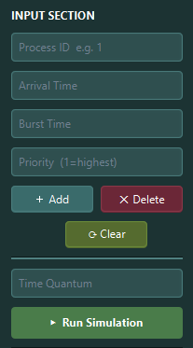
1.User can Add process by entering all requirements
They should be Non-negative values and the highest priority is 10
Also no duplicated IDs
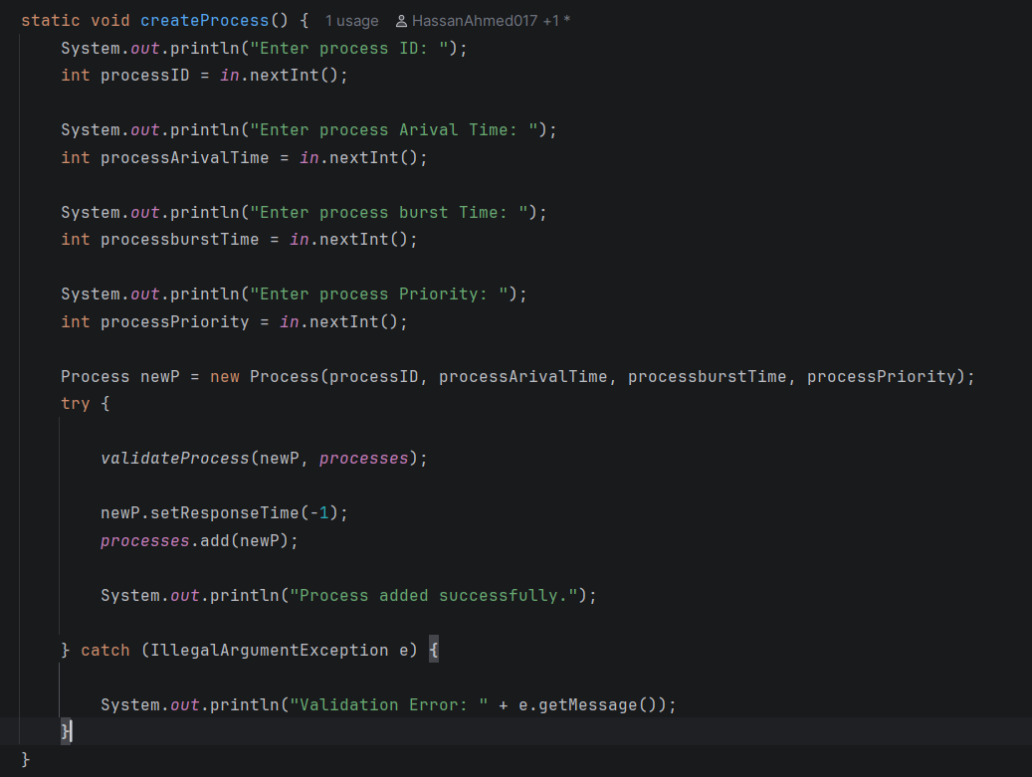

2
2.User can delete a process be selecting it from process table then press delete
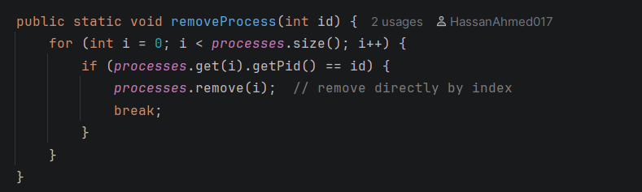

3.User can clear process table by clicking Clear button
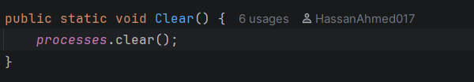
It clears process Arraylist and all the previous results

4.user can enter a Quantum and It should be non-negative value
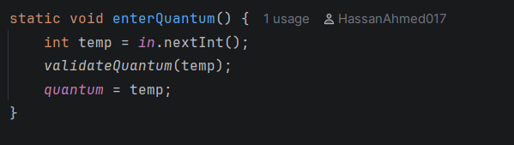

3
2.Process Table:
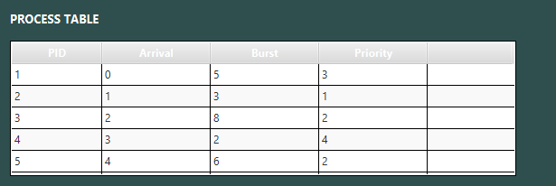
Here are all the entered processes and their Arrival time, BT and Priority

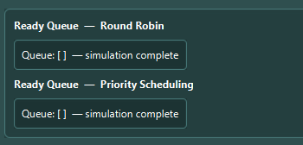
This is the ready Queue block, it looks like this when simulation ends
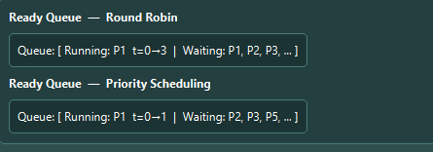
While running

4
3.Results:
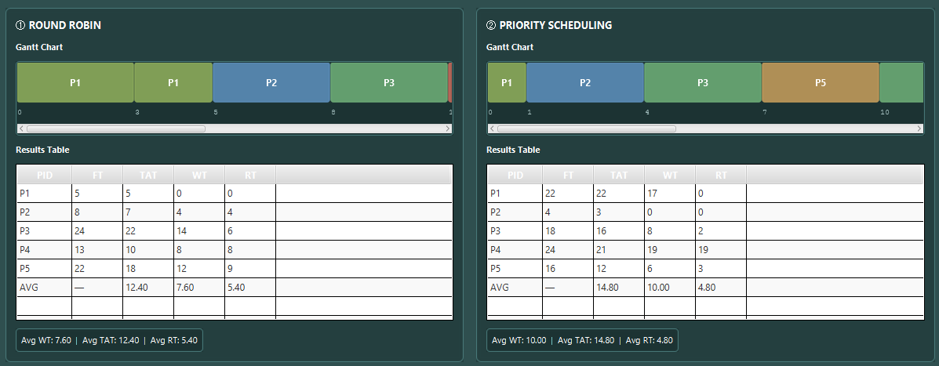
Here are all the results of the processes of PQ and RR.
FT: finish time of each process
TAT: Turnaround Time (time process took since it entered ReadyQueue)
WT: waiting time (process in RQ but not being executed)
RT: response time (First time the process entered RQ)

Here the App Displays which process was better.

5
4.Comparison
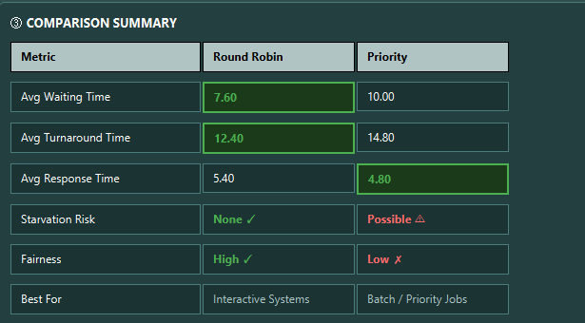
In this section the app shows which process was better in what, if there was any starvation risk, if there was fairness or no and finally what this Scheduling Algorithm better for

6
5.Final Conclusion:
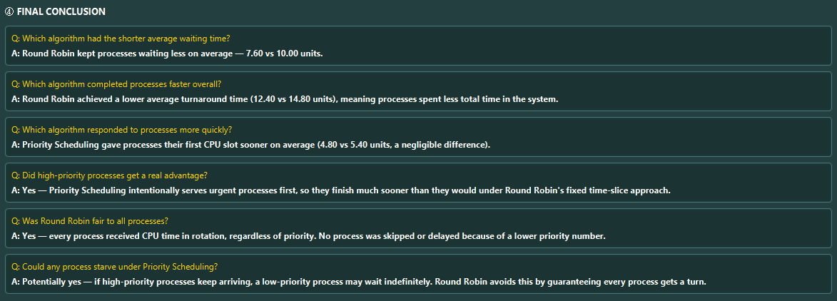
These are some Q&A to determine whether RR is better or RQ
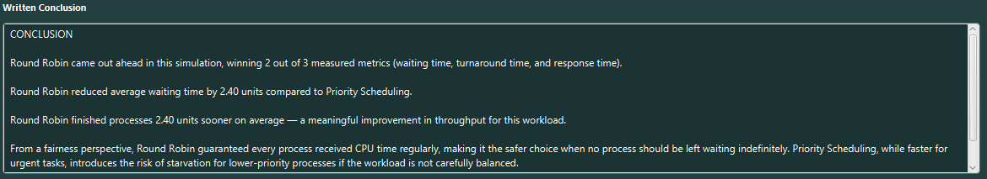
This is a written conc with more details

7
6.Test Scenarios
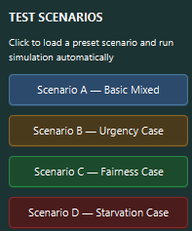
Each button clears RQ then loads it with different processes to test:

1.Normal workload (Basic mixed):
Loads 5 processes with varied arrival times, burst times, and priorities.
Serves as the baseline comparison between Round Robin and Priority Scheduling.
Round Robin distributes CPU time evenly; Priority Scheduling favors lower priority numbers.
Expected: RR wins on fairness; PQ may win on waiting time for high-priority processes.
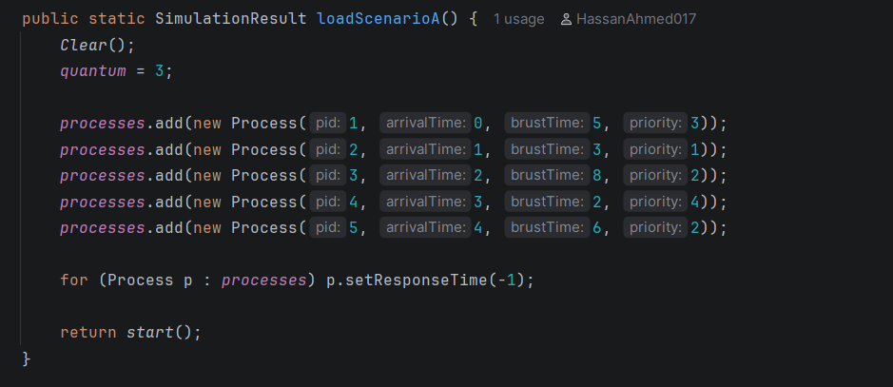

8

2.Urgency case:
Loads 5 processes where P3 and P4 have priority=1 (highest urgency).
Tests whether Priority Scheduling visibly serves urgent processes before others.
Under PQ, P3 and P4 finish significantly earlier than under Round Robin.
Expected: PQ clearly outperforms RR in response time for high-priority processes.
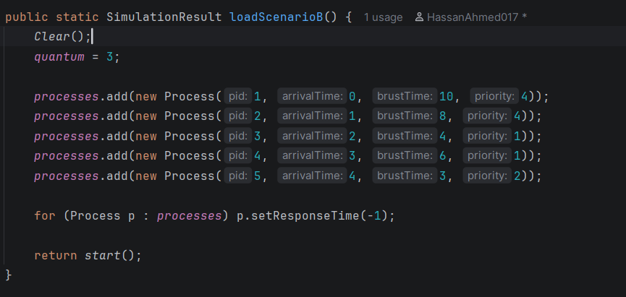
3.Fairness case:
Loads 4 processes all arriving at t=0 with equal burst time (9) and equal priority (2).
Tests whether Round Robin distributes CPU time evenly across identical processes.
Under RR all processes receive equal time slices and finish at similar times; PQ is arbitrary.
Expected: RR shows perfect fairness; PQ finishes them sequentially with no fairness guarantee.
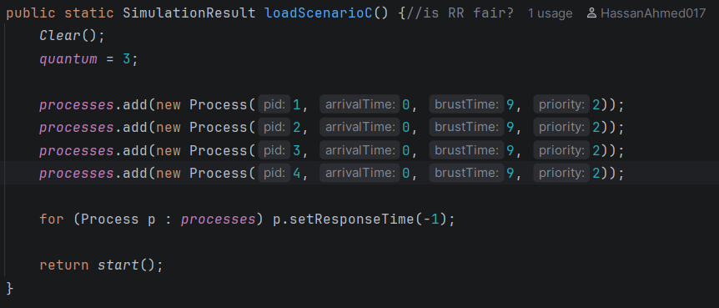
9
4.Starvation case:
Loads 4 high-priority processes (priority=1) and one low-priority process P5 (priority=4).
Tests whether a low-priority process suffers significantly longer waiting under Priority Scheduling.
Under PQ, P5 waits until all 4 higher-priority processes complete before receiving any CPU time.
Expected: P5 has near-zero wait under RR but maximum wait under PQ, demonstrating starvation risk.
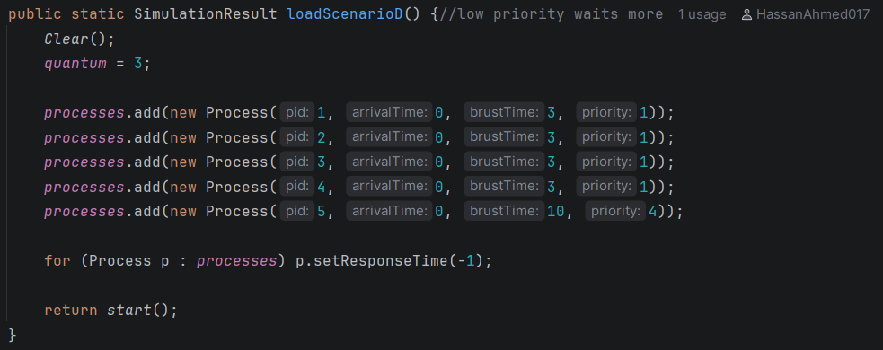

7.For more Details and code: Git-Hub repository

10

